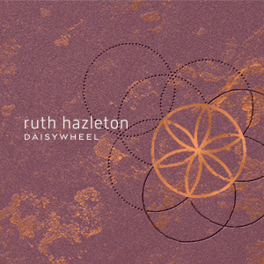

RUTH HAZLETON - DAISYWHEEL
The remarkable new album.
Released November 22, 2019 via MGM Distribution.
The daisy wheel (also known as a 'hexafoil') is a compass-drawn circle with six petals within it. The symbol has been found etched into mantlepieces, door frames, window frames and furniture for centuries in Britain and more recently, in Australia. A folk superstition or ritual without any recorded written or oral explanation, scholars now agree that the daisy wheel symbol served the purpose of protecting a household or building by warding away bad spirits and dispelling ‘darkness’.
DAISYWHEEL is also the name of the highly anticipated debut solo album from one of Australia’s most respected folk singers, Ruth Hazleton. A multi-award-winning musician, singer and songwriter, Ruth has toured nationally and internationally in a career spanning twenty-five years. Over this time, she has performed and recorded with iconic musicians from all over the globe including Andy Irvine (IRE - Planxty), Nancy Kerr (UK – 2015 BBC Folk Singer of the Year) and Bruce Molsky (USA).
Equipped with an electric guitar tuned to DADGAD and a 5-string banjo, Ruth Hazleton and producer Luke Plumb have created a stunning and diverse sonic experience; a confluence and collision of past and present, ancient and contemporary and a cross-cultural zeitgeist. A lyrical voyage of history, struggle & resilience in song, the album is in itself a musical daisywheel.
Of the ten songs appearing on the album, four are original, five are traditional (English, American & Swedish in origin) and one is a Henry Lawson poem Ruth composed the music for. The stories are varied, political and strident; whether wrangling with matters of the heart, dealing with themes of injustice, conflict, displacement and defiance.
Musically, this album is very adventurous; incorporating all of the influences that have shaped Ruth’s musicianship over the years and in many ways escapes strict boundaries of genre. There are flavours of Eastern European music, Middle Eastern music, Celtic music, old-time American music, straight up rock & roll, folk rock, washes of electronic programming and beats, ambience and a salute to one of Ruth’s great genre loves; British trip hop and downbeat.
DAISYWHEEL was engineered and produced by long-time friend and collaborator Luke Plumb (Shooglenifty, The Circuit) and mixed/mastered in collaboration with Scottish engineer and producer Mattie Foulds (Karine Polwart, Lau, Eliza Carthy & Norma Waterson, Shooglenifty, Kathryn Tickell, The Unthanks and Bella Hardy).

The musicians who appear on the album come from a range of musical backgrounds, including traditional, rock, pop, modern jazz and contemporary folk, and include:
Ruth Hazleton: Vocals, Electric & Acoustic Guitars, Clawhammer Banjo, Piano & Shruti Box
Luke Plumb: Electronic Programming, Fiddle, Piano and Acoustic Guitar
Oscar Neyland: Double Bass & Bass Ambient Effects
Justin Olsson: Drums & Percussion
Tim Meyen: Cimbalom
Paddy Montgomery: Oud & Yayli Tambur
ALBUM LAUNCH & FESTIVALS
- Official Melbourne Album Launch – Thurs 20 Feb @ The Spotted Mallard, Brunswick
- Port Fairy Folk Festival 6-9 March (VIC)
- National Folk Festival 9-13 April (ACT)
QUOTES:
"New production ideals meet old tunes, old poems are adapted, new songs are written on old themes, traditional tunes find themselves underpinning contemporary lyrics. Like the Daisywheel on the album’s cover everything is cyclic and self supporting, the final picture is arrived at via any number of musical detours.

What emerges is a self-assured work of great ambition - and no less listenable for that. Recorded between Tasmania and Scotland under the guidance of Scottish auteur Luke Plumb (Shooglenifty/Andy Irvine/The Mae Trio) Daisywheel is a great sounding record, the instrumentation and playing as logical as it is modern, the production as supportive as it is appropriate... All the tradition and innovation in the world is meaningless if the recording doesn’t grab the listener and this is where Daisywheel triumphs. Put simply it’s a record with traditional roots that could take its place and hold its own on any current playlist". ~ Mick Thomas, November 2019
“Whether a traditional song or a song of her own making, Ruth approaches her material with great understanding. Deeply concerned with the political and social, her convictions are intrinsic to the passion behind her music - evident in the strength of her music and her voice”. ~ Andy Irvine (Ireland)
“With an easy but refined musicality, it is her deep knowledge of folk music traditions, a historian's eye and a storyteller's heart that makes Ruth Hazleton one of Australia’s most exciting artists”.
~ Lucky Oceans
“Ruth Hazelton's vast knowledge of folk music tradition saturates her own songs. She is a 'real deal' songwriter”.
~ Kat Goldman (Canada)
“Ruth Hazleton is the rarest of artists. A sylvan voice, an experienced player’s chops, a deep well of tradition to draw on and the ability to write songs that sound older and more lived in than most contemporary music”.
~ James Keelaghan (Canada)

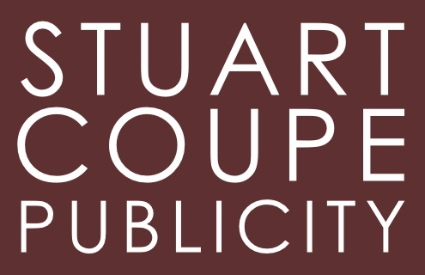
For further info, interviews, music, photos, and off kilter life advice:

STUART COUPE @ STUART COUPE PUBLICITY

EMAIL coupe@laughingoutlaw.com.au
www.ruthhazleton.com

